Date: January 8, 2023

Re: TM2500 Power Solutions

See information on the TM2500 power solution. We have eight (8) units available. All have low hours. Three (3) u nits are ready to operate, and five(5) units require a hot section inspection (HSI) overhaul ifrequired, updated operating system, and general maintenance.

This is covered in our cost and requi res appox. three weeks in the shop, per unit, prior to release with full GE warranty.

Units come with full spare pa rts, warranty, shipping, and set up - if required. With the purchase of all eight units, a spare engine will be included.
The units are multi-fuel and can operate on full or mixed hydrogen.

We recommend starting with the three (3) u nits pu rchase and twenty percent (30%) deposit on the additional five (5) units, but any amount can be purchased.
Please note all units subject to previous sale and can only held with a purchase or deposit.

Price:

TM2500 Units Installation and start-up
$ 33,000,000.00 each
$ 500,000.00 each

If required
Steam Turbine and HRSG $13 900,000.00 each (one unit required for two TM2500
units)

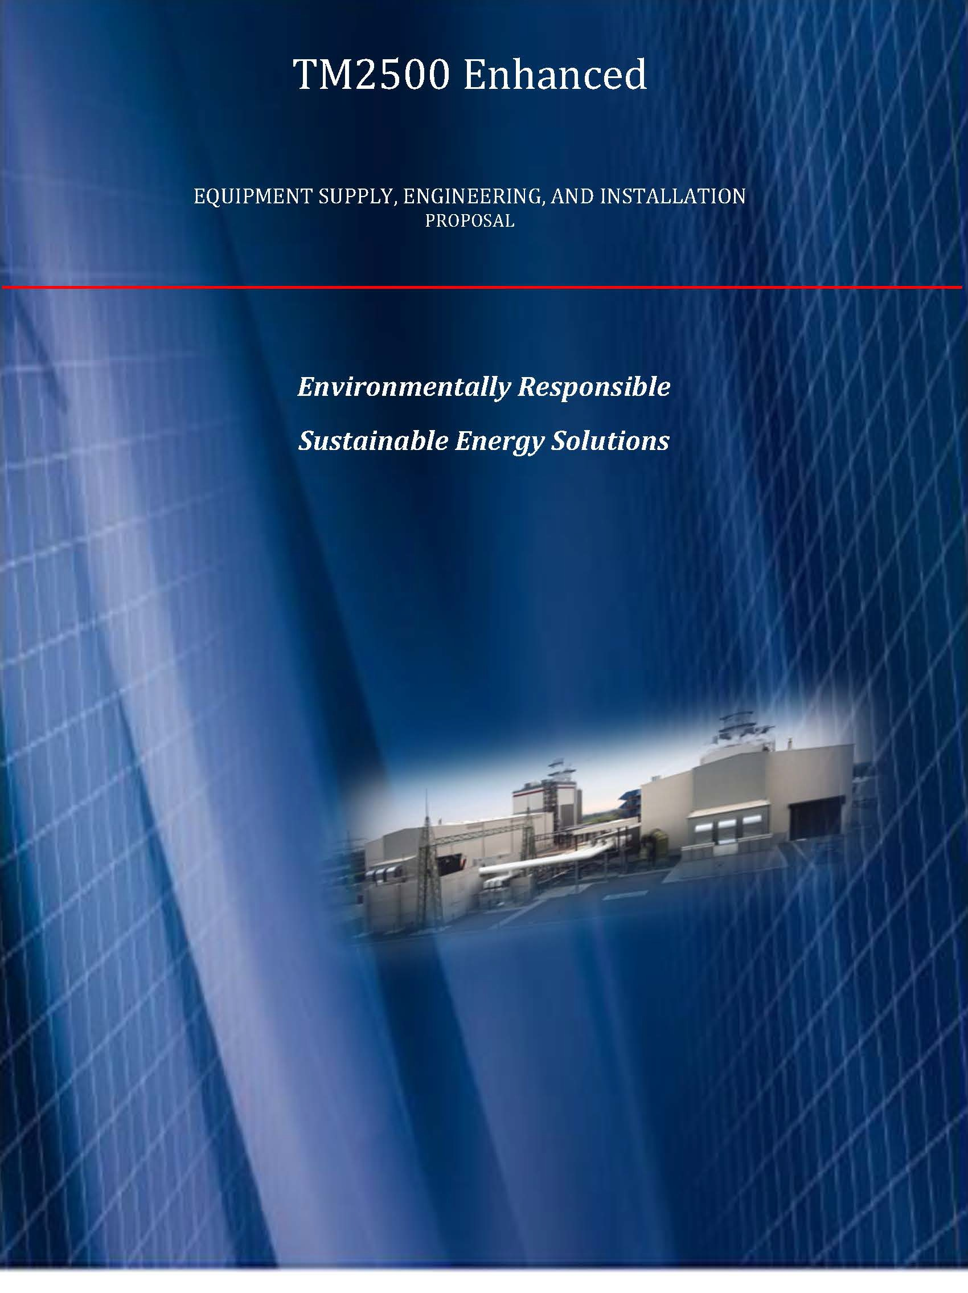

Table of Contents
General Scope of Supply Summary 3
Proposal Design Basis 3
Civil Design 4
Electrical Design 4
Mechanical Design 5
Security 5
Miscellaneous 5
Project Interfaces 5
Codes and Standards 6
Engineering 7
Organizational Chart 8
Equipment 9
General Electric TM2500 9
Services 16
Transportation 17
Schedule 17
Footprint 18
Preliminary Scope of Work 22
Pictures 24
Installation Pricing 27
Optional HRSG and Steam Turbine 27

Z I P a g e

General Scope of Supply Summary

TM2500+ Mobile Dual Fuel S0/60Hz. 30 MW units run ning as simple cycle with the option
in the future to run as a 2 to 1combined cycle increasing the power output to 50 MW per unit.

Engineering, Installation and Commissioning Services, Tooling, Spare Pa rts, LTSA etc. provided. Equipment will have all latest controls and auxiliary systems. All test reports and certifications will be made available.
All units are man ufactured based on 50 or 60 cycle application. Supplier will facilitate all aspects of the purchase sale transaction conveying clear title and reassignment of all equipment used on site and transfer all remaining warranties and entitlements attached to any and all assets. Transportation, site development, startup, and additional warranty coverage arranged and negotiable through Supplier, OEM or other 3rd party service providers. Supplier can provide operations and a 10 and 20 year LTSA under a separate contract.

Proposal Design Basis

Limited Plant Design Criteria were available during the preparation of this proposal and have limited the front-end engineering design ("FEED"). Be advised, as some of the Bala nce of Plant specification and sizing might be changed to accommodate unforeseen factors.
1. Site Location or Layout for site has not been specified.
- No geotechnical studies have been provided to confirm civil design or plant orientation.
- Electrical Interconnect Studies have not been performed to confirm electrical design and have limited electrical scope to the generator terminals.
- Fuel interconnect studies have not been performed. Intercon nection is at the TM 2500 on base interconnect points provided
- Air Permitting and exhaust treatment are not considered, but will meet all US standards
- Plant design life is for minimum of 15-years with no Maximum from Commercial Operation Date ("COD").
- Due to unstable market conditions, all tra nsportation, material, and labor pricing may have pricing escalators to accommodate u nforeseen costs outside of our control.

Proposal content, price, and schedule are subject to change based on the emergence of additional information including without limitation, environmental and utility requirements, fuel gas, raw water, potable water and electrical grid characteristics, wastewater and local

- I P a g e

noise limitations, other local conditions and events, and the results of detail engineering and/ or constructability reviews with CUSTOME R and other parties having an interest in the Work
The following assumptions and clarifications are presented to describe the engineering approach, equipment design, and estimated price that will be used based on the absence of any other project specific information.

Civil Design

1. A clean, level site with free and clear access, suitable for spread footing/mat foundations is to be provided by CUSTOME R. The load bea ring capacity of the prepa red site is assumed to be a minimum of 3000 psf at three feet below finished grade.
- The site soil characteristics are suitable for a standard subsurface ground grid system without the need for installation of additional ground wells.
- Adequate construction laydown area is available on or adjacent to the proposed construction site.
- No site development is req uired except for structural excavation.
- No site environmental cleanup is required.
- Site de-watering is not req uired.
- All excavation is accomplished through conventional methods and blasting is not required.

  - Excavated materials are suitable for structural backfill. Any excess excavated material will be disposed of onsite. Any requi red offsite disposal is to be handled by CUSTOME R.
  - No subsu rface obstructions, such as existing foundations, large boulders, ledge rock, rock requiring equipment larger than 3/4 yard rubber tire backhoe, hazardous waste, archeological artifacts, undisclosed utilities, or other unsuitable and unexpected material, structures, etc.
  - Storm water runoff is by surface drainage to the battery limits. No runoff is assumed from adjacent areas. No provisions are included for storm water treatment or containment.
  - Suitable concrete batch plant available producing a minimum capacity of 1,000 cubic yards of 4000 psi quality concrete.

Electrical Design

    - Electrical interface is at the high voltage connection in the switchgear cubicle.
- Utility will provide all high voltage electrical interconnection studies, settings, and other relevant line and load flow studies.
- 1 P a g e

- Above ground cable installation is acceptable at the discretion of CONTRACTOR.
- Standby power capability will be provided for 480 VAC, 60 Hz loads.
- A 480 VAC power supply shall be supplied during site construction.

Mechanical Design

1. All waste liquids will be delivered to a buried 200-gallon storage tank per GTG with the battery limits by CONTRACTOR for disposal by CUSTOMER
- Proposed equipment may be subject to change as necessary by local environmental requirements, detail engineering and or constructability reviews.
- Above ground pipe installation is acceptable unless otherwise specified by CUSTOM ER.
- Use of above ground high pressure hoses is acceptable.
- Emissions monitori ng equipment and/or testing is not provided.
- Suitable cranes are readily available within country.

Security

1. CUSTOMER will provide site security during construction.

Miscellaneous

- Engineering review and approval cycles to be a 2-day meeting.
- Site is not classified.
- Environ mental impact study is by others, if required.
- Air Permit and Site Studies by others. All permitting is the CUSTOMER responsibility. CONTRACTOR will assist where applicable
- Plant is assumed to operate on a base load.
- Commissioning spares for BOP are included.

Project Interfaces

- Gas Fuel will be delivered to site. Fuel will meet General Electric standards.
- Storm Water: Site to be graded by CUSTOMER for collection of storm runoff generated onsite to a single water discharge poi nt.

- 1 P a g e

3. Temporary Erection Supplies: Water and electrical power for construction is to be provided at power plant boundary.

Codes and Standards

CONTRACTOR will design the power plant in general accordance with traditionally accepted power plant building practices as follows:

Building Codes, Standards, and Ordinances
- UBC, 1997, except electrical installations

Government Codes, Standards, and Ordinances
- Occupational Safety and Health Act (OSHA) - 29 CFR 1910, except Section S
- American Society of Mechanical Engineers (ASME)
- ASME Boiler and Pressu re Vessel Code
- ASME B16.S - Steel Pipe, Flanges, and Fittings
- ASME B16.34 - Steel Valves
- ASME 631,1-Power Piping
- ASME B31 .8 - Gas Transmission and Distrib ution Piping Systems
- ASME B133.2 - Basic Gas Turbine
- ASME B133.3 - Gas Turbine Auxiliary Equipment
- ASME B133.4 - Gas Turbine Controls and Protection Systems
- ASME B133.S - Gas Turbine Electrical Equipment
- ASME B133.8 - Gas Turbine Installation Sound Emissions
- NEC - National Electric Code
- ASME Performa nce Test Codes

Industry Standards
Applicable standards are issued by the following industry organizations:
- ACI American Concrete Institute
- ASCE American Society of Civil E ngineers
- AGA American Gas Association
- AISC American Institute of Steel Construction
- AISI American Iron and Steel Institute
- ANSI American National Standards Institute, except for electrical systems covered by IEC
- API American Petroleum Institute, except for electrical systems 6 I P a g e

- ASH RAE American Society of Heating, Refrigerating, and Air-Conditioning Engineers
- ASME American Society of Mechanical Engineers
- ASTM American Society for Testing and Materials
- AWS American Weldi ng Society

- AWWA American Water Works Association
- HEI Heat Exchange Institute
- HI Hydraulic Institute Standards
- IEEE Institute of Electrical and Electronics Engineers, where not covered by NEC
- IP Institute of Petroleum
- ISA Instrumentation, Systems, and Automation Society
- ISO International Organization for Standardization
- MSS Man ufacturer's Standardization Society
- NEC National Electric Code
- NEMA National Electrical Manufactu rers Association, where not covered by NE C
- NFPA National Fire Protection Association, except for electrical systems not covered by NE C or other international electrical installation standards

Engineering

Except where expressly described as a CUSTOMER responsibility, CONTRACTOR will provide all requi red engineering services, design briefs for major systems, drawings, and documentation to include facility Operation and Maintenance ("O&M") manuals necessary to install the supplied equipment.
Engineering cond ucted as:

  - Basic Plant Engineeri ng
  - Drawings drafted in AutoCAD format. Spreadsheets and written docu ments will be created
in Microsoft Office formats.
  - Equipment vendor drawings will be submitted in Adobe pdf format.
  - CONTRACTOR will post documents and drawings to a project cloud hosted site.
  - Drawings provided will include: o Civil
    - Electrical & Controls o General / Plot Plan
    - Instrumentation o Piping

7 1 P a g e

Organizational Chart

1Project General Man er -£PC

1 1t e ma no tg r l P; r, oc u re m en t;Fo ll rwi u p ) l f------1-------..J 2 lechnlal Ad1nsots -GT, Ctitllrol

1Site Ctructioo Manager
Mechaniol lnstallanon GT Electncal lostalLltlon i&C lnstalatlon GT & IStanup 1eam General
& BOPTcam GT&BOPTe m BOPTc ITI
1 n1 controller

2 Mechat»ea l EJIGlneer 2 Electrical ineer 2 Commissioning 1Material controlle<
Eni;:inet"rS

2 Mechanocal Supeniisor lc:otr\tttiSSionillfl IliSE S.i<or

SJJpervisors

2 M1 TrdiniQ 1 2
Electricians
IZ l&C Tnioons
lCl\o\I supeMSor

IWelder I Adml111Stnt l 1te Asst.
I

2 Hel per 1Helper ILNI
lMillwright technlcl.an 2 Vehicle Orwers

4 1iefoers

Note:Tot al m.lnpowe< fioclud.ng7 helpers}:

Crane & Forklift services - rental (operator and rig,gers from local sourcesl

B l P a g e

Equipment

General Electric TM2500

The TM2500 MGTG set is a trailer mounted mobile power package. The trailer system allows for simplified tra nsportation and set up of the package. The TM 2500 MGTG set typically consists of three trailers: the Turbine Trailer, Generator Trailer, Control House
Trailer, as well as an optional Transportation Trailer. The basic scope of supply for each of these trailers is described in the following subsections.

Turbine Trailer
The main deck of the turbine trailer contains an inlet silencing system for the tu rbine and the tu rbine module. Located on the gooseneck of the trailer is the auxiliary skid, which contains the TCP (Turbine Control Panel) along with various package support systems. When the package is fully installed the tu rbine trailer assembly is fitted with the air filter modules,
tu rbine exhaust silencer and ventilation fan assembly for the tu rbine enclosure.

Trailer and optional stinger
a three-axle, air ride suspension trailer with two steerable axles is used to transport the tu rbine trailer components. The optional stinger has a single-axle and is used to assist in weight distribution to meet U.S. and Canadian transport requirements. At the job site, the
tu rbine trailer is connected to the generator trailer. Landing legs are provided to support and level the equipment at the jobsite.

Turbine Enclosure
The turbine trailer is supplied with a weatherproof, acoustic enclosure for the turbine which provides ventilation and fire system contain ment. The enclosure is designed for noise abatement to 90 dB(A) for liquid fuel and 87 dB(A) for gas fuel. The enclosure is completely assembled and mounted over the equipment prior to testing and shipment. Provisions for
tu rbine removal and person nel access are included.

Gas Turbine Engine
Located inside the turbine enclosure is a General Electric gas turbine engine (Model LM2SOO+G4™ ); the turbine engine is equipped to operate on liquid fuel or natural gas with or without water injection. The turbine engine is mounted to the turbine trailer which is independent from the generator trailer.

9 I P a g e

Fire Protection Aerosol Canisters
Fire protection aerosol canisters are located on top of the turbine enclosure, included as part of the ventilation fan assembly. These canisters are connected to the fire protection system located in the Generator Control Panel (GCP) and provide the necessa ry extinguishing agent in the event of fire inside the enclose.

Auxiliary Skid
The auxiliary skid is a compact installation of several systems and equipment and is positioned on the gooseneck of the turbine trailer. This skid contains a variety of support equipment includi ng a TCP, the Hydraulic Start System with shared turbine lube oil reservoir, Turbine Lube Oil System, and the Off-Line Water Wash System. Some of the systems on the skid contain transmitters that provide remote system monitoring. The pressure and pressure differential transmitters have instrument valves in their feed lines to simplify maintenance.
Mechanical interconnections are provided to allow the required interfacing between the auxiliary skid and the control house as needed, otherwise wiring is factory installed.

Turbine Control Panel
The Turbine Control Panel mounted on the auxilia ry skid will include:

- TX3i
- Bently Nevada
- VersaMax Controllers
- Jaquet T401
- Servo Position Controllers (for variable geometry and compressor discharge)

Hydraulic Start System
The hydraulic start system mounted on the auxiliary skid will include:

- Hydraulic Pump & Motor
- Oil Reservoir (shared)
- Various Temperature Elements, Pressure Gauges, and Hydraulic filters Turbine Lube Oil (TLO) System
The synthetic lube oil system mounted on the auxilia ry skid will include:
- Tank Flame Arrestor
- Turbine and Hydraulic Lube Oil Reservoi r
- Tank Demister
- Turbine / Hydraulic Start Fin Fan Heat Exchanger
- Off-line Water Wash System
The water wash system mounted on the auxilia ry skid will include:

10 I P a g e

- Polyethylene Tank
- Water Inlet Shut-Off Valve
- Suction Pump
- Strainer
- Air Filter Assembly and Silencer Enclosu re
The air filter assembly contains combustion and ventilation air filtration equipment includi ng pre-filters, high-efficiency filters, a ventilation fan assembly, and a concentric intake silencer in an enclosure. The turbine compartment is fully ventilated by a ventilation fan which draws filtered air from the silencer enclosu re.
- Dual Fuel with Water Injection System
All components for the dual fuel system with water injection, with the exception of the gas fuel skid, are located on the turbine trailer. All components come preassembled from the factory. Mecha nical interconnect locations for liquid fuel and water are provided for customer connection just below the tu rbine gauge panel.
- Gas fuel system major components include:
•Gas Fuel Duplex Filter Assy
  - Gas Fuel Vent Valve
  - Gas Fuel Purge & Bleed Ball Valve
  - Woodward Gas Fuel Valve
  - Gas Fuel Purge Check Valve
  - Purge Valve
- Liquid fuel system major components include:
  - Liquid Fuel Y strainer
  - Purge & Bleed Valve
  - Liquid Fuel Pump / Motor
- Primary and Secondary Shut-Off Vale
- Liquid Fuel Ball Valve
- Fuel Manifold
- Liquid Fuel Relief Valve
- 30 Fuel Nozzles
- Liquid Fuel Duplex Filter Assy
- Return Check Valve
- Liquid Fuel Control Valve

Water Injection System
GE provides the necessary controls, metering equipment, and interconnecting piping within the turbine enclosure. All piping is stainless steel, and the valves are trimmed with stainless steel. Water injection can red uce NOx emissions to 25 ppm (51 mg/ Nm3) for gaseous fuel
and to 42 ppm (86 mg/ Nm3) for liquid fuel. The customer must provide a supply of 111 P a g e

pressurized water in accordance with the Injection Water Quality Specification MID-TD- 0000-3.

Gas Fuel Skid
The gas fuel skid is transported on the gooseneck of the generator trailer and provides the final filtration of gas fuel to the package. When in operation the gas fuel skid is connected to the turbine trailer with the only GE mechanical interconnect provided with the package.

Turbine Exhaust
The LM2SOO+G4™ gas turbine exhaust flows through an exhaust collector and roof mou nted exhaust silencer. The standard TM2500 GENS exhaust collector exit is oriented in the upright position. The exha ust collector provides a direct path into the turbine exhaust silencer. The exhaust collector consists of an inner and outer duct forming a diffusing passage from the power turbine rear frame.
Exhaust system components include:

  - Exhaust Collector
  - Exhaust Silencer

High Speed Coupling Shaft
A high-speed flexible coupling shaft connects the low-pressure tu rbine/power turbine to the generator. It consists of a forward adapter which mates with the power tu rbine, two flexible coupli ngs, a distance piece, and an aft adapter which mates with the connected load. The flexibility in the coupling allows for minor deviations in- between the turbine and generator shafts, this flexibility aids in successful connection between the turbine and the generator.

Alignment System
The Laser Align ment System consists of the following components:

  - IP Camera (2)
  - Power Switch
  - Laser (Green)
  - Tablet (M icrosoft Surface)
  - Light

Generator Trailer
The main deck of the generator trailer contains the generator, generator ventilation,

12 I P a g e

generator lube oil system, and switchgear. The gooseneck of the generator trailer may be optionally removed in operational configurations to reduce overall footprint.
Located at the rear of the generator trailer is a docking station that provides the male interface required to connect the turbine and generator trailers together for the operational configuration.

The Generator Trailer consists of the following components:

- Generator Trailer with stinger for transportation
- Generator Ventilation (when package is fully assembled)
- Generator
- Switchgear
- Generator Lube Oil Skid

TM2500+ General Arrangement Auxiliary Trailer

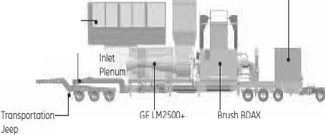Inlet Filter Assembly
I
....._ Exhaust Srock Switchgear

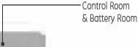Trailer - Gooseneck

Gos Turbine 62 l70ER Generator

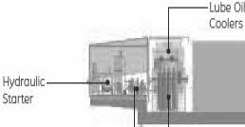ETronsportotioo Stinger

fuel/Wote, -- Pumps

TurbineEnclosure F[e Suppression

Genera tor
The AC generator operatesat a synchronous speed of 3,600 rpm (60-Hz applications) or 3,000 rpm (SO-Hz applications), eliminating the need for a speed-reducing gearbox during simple­ cycle operation. TheTM2500 generator is an air-cooled Brush generator (Model BDAX62 -
170E RT) with an air filter assembly and exhaust assembly.
Dry coupled to the engine,the generator is mounted directly to the generator trailer. This arrangement enables engine/generator shaft alignment to be adjusted with the turbine trailer with the suspension system of the turbine trailer, while the generator remains fixed.

Genera tor Lube Oil (GLO) Skid
The GLO skid is a compact installation of generator lube system equipment on the generator trailer and is positioned on the generator end of the generator trailer. The GLO skid contains 13 I P a g e

the generator lube oil air/oil separator, GLO tank, DC lube pump and GLO filter.
The skid contains transmitters that provide remote system monitoring. The pressure transmitters have
instru ment valves in their feed lines to simplify maintena nce. The mineral lube oil system for the generator will include:
- GLO Filter
- GLO Tank
- DC Lube Oil Pump
- GLO Fin Fan Heat Exchanger
- GLO Air / Oil Separator
- GLO Pressure Control Valve

Switchgear
The TM2500 has a self-contained, metal clad switchgear; it is located on the front portion of the generator trailer.

The switchgear houses the following components:

- Generator breaker
- Current Transformers
- Buses
- Voltage Transformers

Generator Ventilation
The generator is supplied with its own ventilation components to provide cooling air solely for the generator. Shaft mounted fans direct cooling air through the generator- unit. The cooling air is then exhausted out of the generator through the exhaust silencer located on top of the generator.

Control House Trailer
The control house trailer includes a lighted and insulated control house. The control house is equipped
with an access door, air conditioner/heater, and a ha ndheld fire extinguisher. The control house trailer consists of the following:
- Control House Trailer
- Control House which includes:

o Human Machine Interface (HM I) o Generator Control Panel (GCP)
- I P a g e

o Motor Control Center (M CC) o Batteries and Chargers

Control house trailer is a two-axle, air ride suspension trailer. At the jobsite, the control house trailer is inter-connected electrically to the turbine and generator trailers. Landing legs are provided to support and level the equipment at the jobsite.

The control house package equipment is described below:
HMI - Control house trailer is a two-axle, air ride suspension trailer. At the jobsite, the control house trailer is inter-con nected electrically to the tu rbine and generator trailers. Landing legs are provided to support and level the equipment at the jobsite.
GCP - The GCP contains the voltage regulator and switches for controlling generator operation. This pa nel also contains local controls the Beckwith Integrated Generator Protection System (IGPS) for monitoring the operation of the tu rbine engine and generator. The fire protection panel and VersaMax modules integrated with the control system PLC. The GCP also houses DC circuit breakers for the distribution of DC voltage throughout the package as needed. The framework of intercon nects required for complete package communications are distributed through this panel via interconnect cables.

MCC - The MCC (motor control center) is a free-standing metal cubicle that houses various low-voltage circuit b reakers, motor starters, and their controls. It is installed in the control house, and also includes a 30 kVA lighting and distribution transformer.
Batteries and Chargers - The TM 2500 has a 24 VDC control system battery system and charger, a 24 VDC fire system battery system and charger, and a 125 VDC switchgear and backup generator lube pump motor battery system and charger. The battery systems are fully wired and mounted in racks located in a separate ventilated compartment in the control house. The stand-up charger unit for all these components is located inside the control house trailer for easy accessibility. The 24 VDC distribution circuit breakers for the fire and gas protection system are located in the battery charger's cabinet.

BOP Equipment

Water Injection Systems
A water injection metering system is provided to red uce NOx emissions for gaseous fuel or liquid fuel operation. Demineralized water is injected into the combustor through ports in the fuel nozzles to produce NOx suppression. Water is supplied to the nozzles by a special water
- I P a g e

manifold. Water injection can reduce NOx emissions to 25 ppm (51 mg/ Nm3) for gaseous fuel and to 42 ppm (86 mg/ N m3) for liquid fuel
GE provides the necessary controls, metering equipment, and interconnecting piping between
the gas fuel skid and the engine. All piping is stainless steel, and the valves are trim med with stainless steel. The CUSTOM ER must provide a supply of pressurized water and liquid fuel in accorda nce with the specifications.

High Voltage System
At the time of this proposal no one line diagram or intercon nect studies have been performed to dictate electrical design. This will be quoted when information is provided on a cost-plus 10% basis.

Exhaust Treatment System
At the time of this proposal no environmental of BACT studies have been performed. At such time this will be added on a cost-plus 10% basis.

Central Control Room
Central Control room will house the plant DCS and serve as the plant hub.

Plant Bulk

  - Civil Bulks - all earthwork to include concrete / rebar and bulks to be provided to include grout, anchors, fencing, and other embedment.
- Mechanical bulks include but not limited to the following - piping, fittings, plant valves, insulation, plant installed instrumentation, platforms, ladders, piping to be field routed.
- Electrical bulks include but not limited to the following - interconnect cables, cable tray/cond uits, grounding, lighting, cathodic protection.
- Painting and Protection by CONTRACTOR.

Services

Installation, Commissioning, and Startup
CONTRACTOR will provide technical advisory supervision, contract person nel, and equipment necessary to install, commission, and start up the GTG and facility to Original Equipment Manufacturer ("OEM") standards.

- I P a g e

Transportation
All transportation provided will be on a cost-plus 10% basis. Pricing has been provided as an estimated budgetary number where applicable.

 |  | Approx. Weight  (lbs.I | Li<W x H  (feet)
Turbine Troileri.2  Without Stinger With Stinger |  | 90,145  95,139 | 55' L x 9.8' W x 13.2' H  69.6' L x 9.8' W x 13.2' H
Generator Troiler1.2  Extendable Stinger set to EU Extendoble Stinger to US Extendoble Stinger set to CAN With Cold Steel Version |  | 157,380  157,380  157,380  161.822 | 68.6' L x 9.8' W x 12.4' H  76' L x 9.8' W x 12.4' H  84' L x 9.8' W x 12.4' H  Dependent on Stinger Setup
Control House Troiler1.2 |  | 47,490 | 41.7' L x 9.2' W x 14' H
TransportotionTraileri.2.3 |  | 49,435 | 43.2' L x 9.8' W x 13.6' H
Air Fi | llter Assemb ly (including support | 8,674 | 17.8' L x 8.3' W x 10.2' H
bracketl2
Switchgear |  | 8,900 | 6' L x 9.4" W x 8.1' H
Generator 62-170EIRT |  | 84,878 | 19' L x 8.9' W x 7.2' H
Generator Ventilation |  | 6,724 | 12.7' L x 8.4'W x 9.1' H
Control House |  | 25,463 | 22.8' L x 8.3' W x 9.4' H
Ventilation Fon Assembly |  | 4,530 | 10.3' L x 8.3' W x 7.9' H
Exhaust Stock |  | 16,3 23 | 12.2' L x 8.3'W x 11' H
Crane2 |  | 9,140 | 5.3' L x 8.3' W x 8.75' H
Generator Air Filters2 |  | 1,600 | 4.4' L x 8.3' W x 8.75' H

Schedule
It is estimated that when the MGTG's are delivered to the site, installation will be 2 weeks per turbine.

- 1 P a g e

Footprint
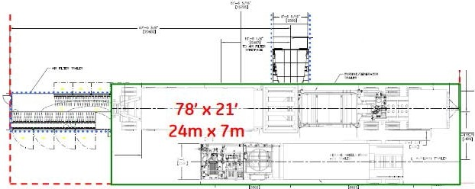Compact Footprint. Ultra Dense Power.
------------ -,
I
107' x 67'
32m x 20m
----------
.,_...,._ ·1. · ----
1

'  - +-  ' |  |  | -

77% reduction in installed footprint
(compared to previous generation TM2500) 1

- imo91notionot wor1<
GE .4..:<oderivotive Gas TorbiMS 1

Presento1ior Slides

18 IP a g e

Entrance to Yard
••
Construction
TrailerI Control Room

13.8 - 138 KV
Transfom1er
33 MVA
(1 x LM2500)
_. W.Nli t(t.ANC'J
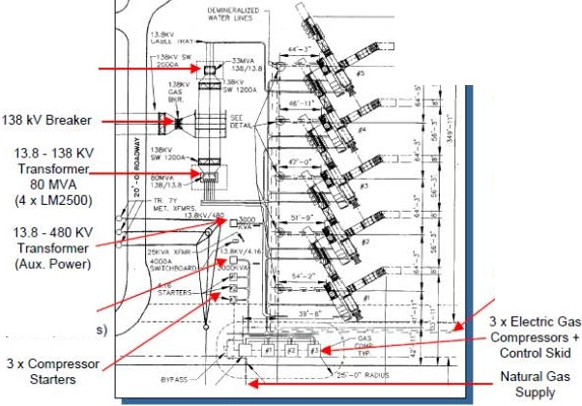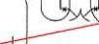k11:l1Nr..
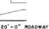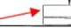 J ,..-.r....-L,.

' <::-------.:.,
l.M!

Minimal site preparation required

Loading may require some foundation modifications
  - Fuel, water, electrical connections all tie into Aux Trailers

    - Low elevation profile (20 ft. max. height)

13.8 - 4.16 KV
Transformer (gas compressors)

19 1 P a g e
DeminWater Supply

$ Customer lntetiace Requirements
Electrical
- Customer required to supply 480 Volt,60 Hz. au:<iliary power to Motor Control Center main circuit breaker (450 kW) located in control room 1Auxiliary Trailer
  - Operatingload approx.190 kW
- Suitable ground gridand lightning protection Natural Gas Fuel
- Customer responsible to supply naturalgas. at 375 (+/- 20) PSIG at a rate of 12,000 pph (200
mmht11/hr or fi msr.f/cfay)
- Must conform to GE Specification MID-TD-0000-1(Natural Gas Fuelfor GE Aircraft Derivative Gas Turbinesin IndustrialApplications)
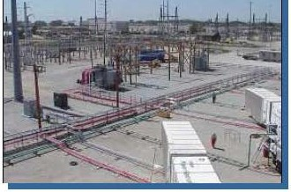Liquid Fuel (Diesel)
•
- Customer responsible to supply liquid fuelat 30 (+f- 10) PSIG,up to 40 GPM (max )
- Must confom1to GE Spedfication MID-TD-
0000-2
Water for NOx Suppression
If desired,customer responsible to supply demineralized water at 15 PSIG (min.) up to 28 GPM (max.)
Must confom1to GE Spedfication MID-TD-
0000-3
Foundation
- Suitable foundation in a secure location

20 IP a g e

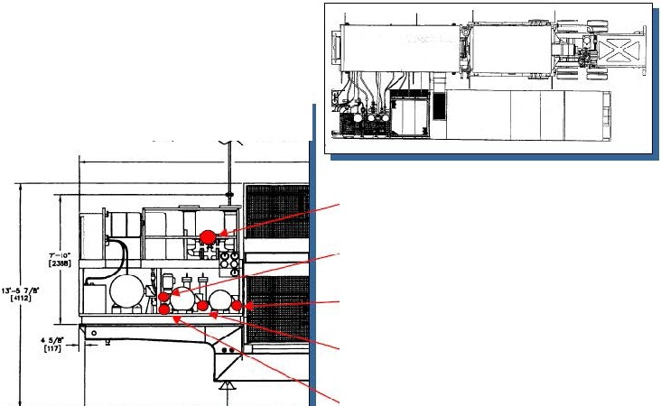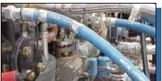8 Interface Connections
Quick disconnect lines between
trailers
- All lines neatly stowed and pre­ connected where possible

27"-5 ?/r ] -,-,
cam: '""" "-..... '""
Natural •
Gas Supply
Liquid
F11A I •
Reh.Im
Water lnj. lnlP.1
Designed for 3-day set-up
where infrastructure is in place
Drawings and detailed requirements allow for site preparation in advance of genset arrival
Wot 1
lnj.
Return

Liquid Fuel Supply

211 P a g e

Preliminary Scope of Work

- 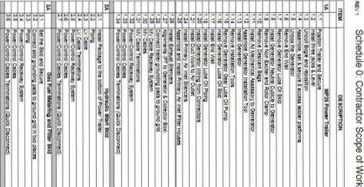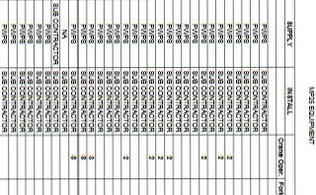I•
• . '• ..,.N ···. • 1i
l-l.+4-1-14-1-1414-1-14-1-1 -1-14+++++++++-+++-'-+-l-+-l-l--<14-1-1-l-l- e
l-l.+4-1-14-l-l-M-1-14-1-1 -1-14-l-l-l-+++++++++ --H--1-1-1--1--1--1-l-+-I- I

0 N
. ..........
." "
II T"

" -·
I I g

22 I P a g e

"."..' DEICRIP'TIOO IUPA.Y

er.neow.
0<mu
..
EITIMATEO MAN-HOU.R....... ...-· -·

- .-
..
..,,,.

,.,,..
FOik Lm ao.r. Rlgg•r ......,,
a.-.-.e .. •
...

set-US:li:IOUIO' $ee ,.,,..
nea sm
.,
&.... '..eOFi ' • 2

4.!
..,
"tOin! 'lO "llY.1'1CS "tt:f In tM.0
,.,,.R..-...CTO't
....
"
OR • ,
'

ins =i11ns ="!M a.e OR 10
.> .'Ccn' m
. c=bes
iatvr, ens.Ttrmr.e:ors<CUD: D!C<:r.n!Ctl
MCO<llt'CTOR 1
£.1 setu ::ntera 8eo;:tt F'VIPS a\.e°""""°'OR • 2

E2 COn!le>:!W!l.g U4S'lO gMr.hlO SUSOONTR. a.e
-u PIM o..eOR
' • 5\JOCONTRl\CTOR IS

u - m
'-' .
,=."!,/,P.S.
g OR '
a.eCA '

" .'Ocn:lolTemil':ir."O:S 'l"!M g. eOA ' "

•• ,., set
all:ld SIO$e-: ,.,,..
- -
..
C02BolU•Raoll Acccem
a.eCA ' • 2 -

., :;:"...'.:n, edSl!O g »1110tn::111ra111tir.o 6 == _a& O.A.
' . .

.:7. -. ,.,,.. '

\'ell;llt002sa. Ntlll »002 ....."""""'°'°' ....
- m !Ei:
' 10

-e;
;
-
=Uea & " S<."".e . ' w
F'<!M a.6CON'i'Rl'CTOR •
Pw.e'. ceOleS Termt:tons{CUI:!( Ols«n ::VIPS ' .

.. ..!:-.eSldO w S« ""' .

..-.
·-
OCnne-:t
-
SW-
_...,Flllltr am
gl'Olnlng »g!Olt'IO 11ra In tiMI es
m .
.
...
. . . -
..
.

Poer.
•• .lOGrr.lol Tetmr:ir.-o:stQU't:k·O'.'so:lnn. "
•

•..
set
se-: Wti:.r ,.,,..
.. '

., OCnned SD:!groin!
a-
k(e

»11ioi.n:s 11ra111tit.o 6 SUSOOMTR.
..... .. •
' J J

-..
'°""""""""-
all:ld
Sid'
,.,,..
,.,,..
a.&CA ' "

.,
s.:. - ¢a!i:S
Poile'JOcn".:olTermrtr.G lCUll:X •
••
- IP4

,.,,..
,.,,..
..... •
S.'.eCCN'11'VCTOR
'
•
a.6CONTIVt.C'TOR •

... set'!.".ece.t a S:eoJre '"
a.ECOJ>l1'RACTOR 2 • '

..........
.. ' e<lllCJ'!'Cr!;

1,C.1 ec Tra1eta,.,ee.:11"e "
"Ste "
,.,,.. ....
  - 2 SUDCONTA/ICTORl:)

'"'
1C,,
ins:.Traerau
m:oe se:&. wre lo:«SS e-f
''" AUTll D
r- a.eCONTFVCTOR
•
,.,.,.. a.&OA; ..
"
....°""""'°'°" •

! .eiil:l C«!Sto, gtlll ....""""""'°'
111.5 kfV siem .?VIPS .W°""""°'OR
"'u;°""'
Q)
OD
P"-'

(")
N

Pictures

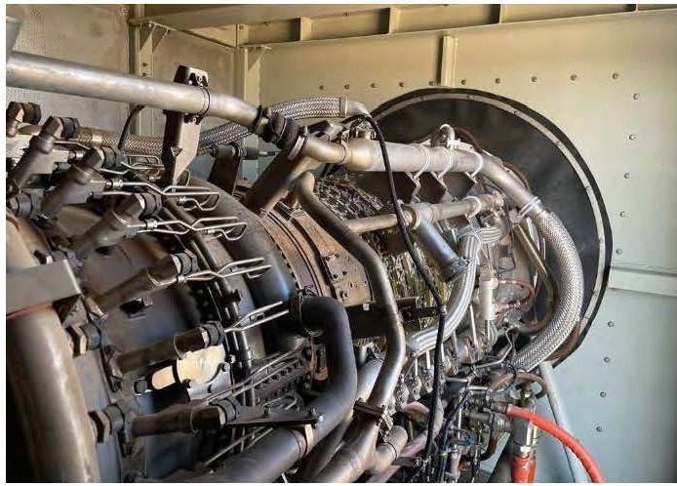

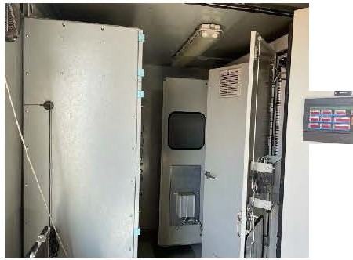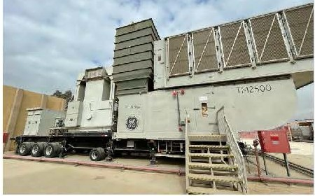;

I
i

24 1 P a g e

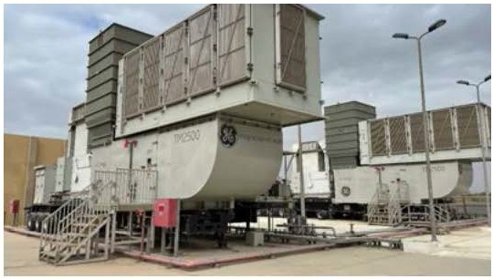

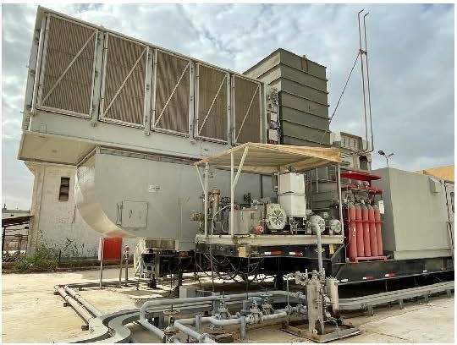

- IP a g e

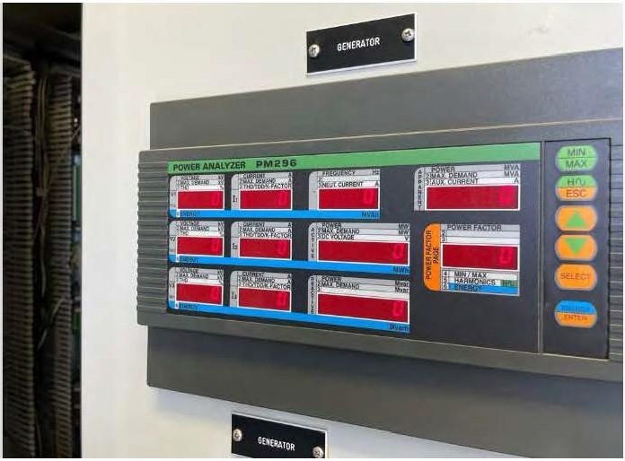

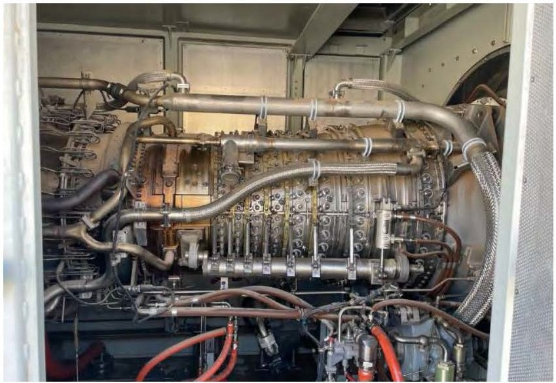

- IP a g e

Installation Pricing

Quantity Description Price Civil Structural
1Buildings - Central Control Room (optional) Sound Mitigation if requi red
Black Start system Mechanical Electrical Instrumentation DCS System
Plant Erection
Equipment Rental Painting
Site Costs Engineering
Project Management Travel & Per Diem TA
Testing Bonding BAR Contingency
Transport to site Import Costs

Optional HRSG and Steam Turbine
Estimated Cost

Included
$534,000.00 (only 1needed)
$40,000.00
$250,000.00
Included Included Included Included
$500,000.00
Included Included Included Included Included Included Included Included
Not Included Not Included Cost +10% N/A

$12,000,000.00

Phase 2, keeps with the concept of mod ulization and limiting work at site, Bridge Power in Ghana is the model. They used 5 TM2500 simple cycle u nits, operating at 33 MW each, and five fully modularised vertical once-through-boilers (OTBs) - designed, engineered, manufactu red and installed by John Cockerill Energy.
Our units will use the same concept but use small modular HRSG Steam turbine units in a 2tolsetup, using Cleaver-B rooks Max-Fire® and installed on trailers by Supplier.

The HRSG pressure pa rts to be manufactured in modular box to maximise shop fabrication by enabling 100% of the pressure parts to be pre-assembled in a single mod ule.

- I P a g e

Benefits of OTB

Key benefits of the OTB include: improved thermal cycling capabilities thanks to the design; superior tube metallurgy; "dry run ning" capability, as already noted; simplified controls; superior operational flexibility; and enhanced modularity and constructability.
In short, the vertical OTB promises lowest lifecycle cost, deriving from flexibility, reliability, and simplicity.

The OTB experiences no efficiency loss due to bypass stack damper leakage, and no maintenance is required on a diverter damper, with less piping and E&I scope, while simplified operation minimises operating costs.
Some other OTB salient features can be summarised as follows:

  - Unrestricted GT start up without holding time from steam cycle.

  - Fast steam cycle start up and shut down capability.

  - A good fit with intermittent renewable energy.

  - Dry running OTB with properly equipped SCR system provides good control of GT emissions in open cycle.

  - Steam temperatu re controlled by feed water flow.

  - Ability to operate down to 30% of GT load while maintaining steam temperature.

  - Low thermal inertia, with thin wall pressure parts throughout and elimination of the thick wall drum.
  - Thin-wall tubes and no limitation on pressure gradient compare favou rably with limitations created by of thick-walled drum.

  - Efficient off-design performa nce: steam temperature can be controlled by the feedwater flow with or without the need for desuperheating.

  - Improved capability for controlling emissions during start up: the SCR is quickly heated up to operating conditions.

28 IP a g e

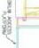
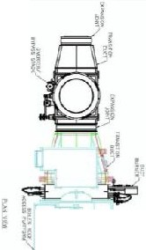

•

O J

Z9 1P a g e

